

Sign in

**Talks**

**>** Reviews

**>** Talks

**>** Gossip

**>** Botd

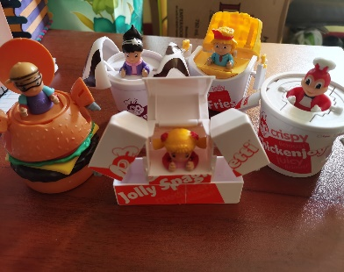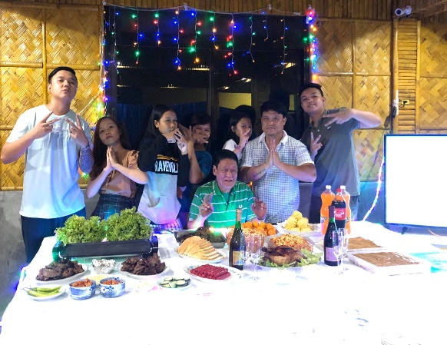

**Trinity**

**Talks**

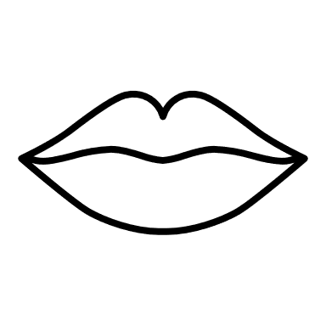

TT

A blogsite of all my review, talks, travels, gossip, and many more

Check out the latest entry! Final Defense things

***Final Defense things***

~~~~~~~ ~~~~~~~~~ ~~~~~~~~~ ~~~~~~~

`` ~~~~~~~~~~~~~~~~~~~~~~~~ ~~~~ ~~~~~~

~~~~~ ~~~~~ ~~~~~~~~~~~~ ~~~~ ~~~~~~~.

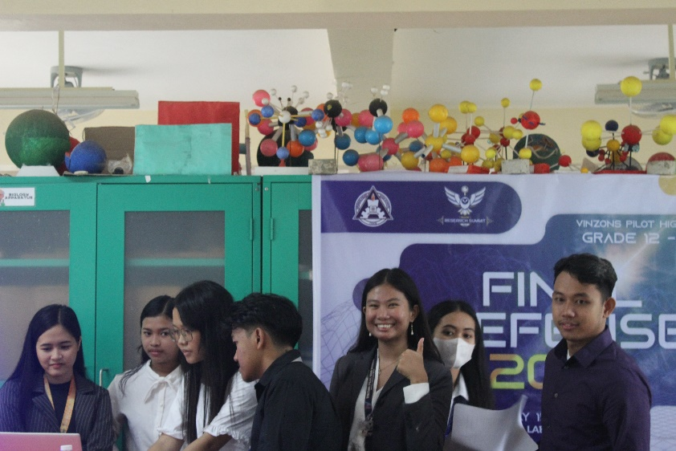

About the author

Trinity

**Trinity Talks**